Mechanics

Modeling

First Try

Before creating the actual model of the automatic leg, I used Solidworks to plan out the whole project. First, I sought out pieces that I cannot use 3D printing. There are two motors that I need to draw. Then, there are some screws, connectors, and others that I also need to buy. These also need to be modeled. After copying down all the bought materials, I turned to the more important part, 3D printed materials. This is the most important work during the modeling.
First, I need two axles to use the motor’s power. The axle needs two different parts to control the two ends of the foot. Some picture. The two axles will help rotate the foot. In addition to the axle, there must be a place to connect the motor and the axle, which means I need a board. I estimated that this will take up half of a leg. An average human leg is around 500mm. So for the board, I decided that it will be around 250mm. The two motors needed to be apart – a safe distance will be 10mm. Then, I designed a circle-like structure to hide the motor, while showing the important features of the motor. Then, I need to connect the axle with the board, using flange bearing. There is still a small problem: there is sliding friction between the axle and the board. So, there is another small equipment must be used: thrust ball bearing. This will change the sliding friction to rolling friction. Rolling friction is smaller than sliding friction, making the axle rotate faster. Last, the axle need to be connected, so another board is needed, and connectors.
Also, guide wheels must be added to direct the strings to the correct place. There then needed to add four braces to support the guide wheels.
In all, the upper part of the model is finished. There is still some last adjustments to the model, but I will move on to the bottom part.
The bottom part consists of a 3D printed leg, springs to absorb the shock, a foot, and a universal joint. 3D printed leg is rather easy, except for the connect part (which is for latter adjustments). I left some places to put the spring and connect the foot with spring. The universal joint is also connected the leg and foot. The foot is originally just a board, but I added depth into it.
Finally, the model looks like this:
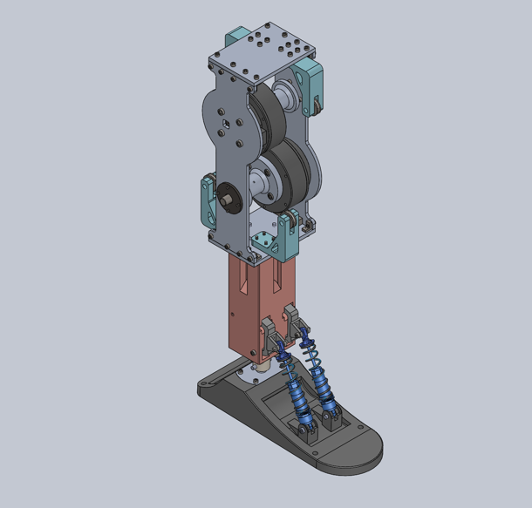

Adjustments

The first version of the model lacked a lot of connectors, making it not a good model. To connect the boards together, a lot of screws must be added. They also must not interfere each other. Also, the bottom leg must add a lot of holes to put in the screws. These are the important parts of this adjustment.
Some other adjustments included the shock absorption springs. It is changed to a four-spring structure for more shock absorption. There is a fun detail, involving leaving a 3mm wide gap for a screw to lock the thing in place.

Building

After gathering all of the materials, I start building the whole leg.
The first thing I started in building the leg is from the bottom part. Connecting the individual parts is harder than I thought. 3D printing materials lacks precision; it cannot crave out the thread that is supposed to be there, so I must use force to crave the thread myself, which is hard. Fortunately, I have electric screwdriver; unfortunately, I do not have a right head for the screw. Which means I must screw it myself. I am not strong, so I asked for some help. Finally, screwing is no longer a problem.
After connecting the bottom leg, the spring is also a problem. There is spring force, so there is some problem in attaching it to the leg and foot. However, it is not a big problem, and soon all was done.
I did some more screwing of other boards and managed to connect the upper part. The only notable part was cutting out the axle. The axles are metal, and I must use finer tools to cut a 10mm diameter of metal rod to the right length. This is quite a challenge.
Finally, I connected the bottom part with the upper part. There is one problem, is that the hole used to screw in the screw is not big enough, making it very tiring. I plan to change this later.
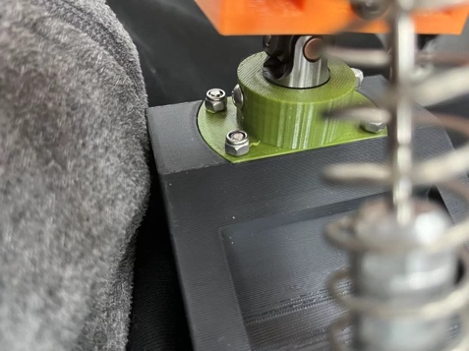
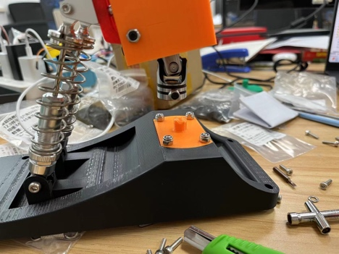
Later, when testing the whole structure, I accidentally broke the part where universal joint is connecting. 3D printing material is not strong enough to withstand all that force. So, I need a stronger 3D printing material, which I then put it together again.
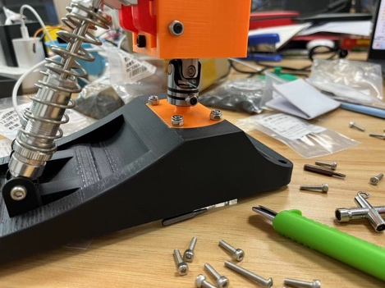

Electronics

Motor Control

The motor we choose to use is RS485. This provides enough force to move the leg, and is not very heavy. There are two motors in my design to control the leg to move in two directions.

We used Arduino to control motor because it is easy to use. At first, I used the board Nano to control the motors, but I changed to board esp32 because for its remote control function. Board esp32 is much easier to use then Nano, as it has built-in TX, RX, and do not need to use a Software Serial. This makes connecting y computer with the motor much easier. So finally, I managed to configure the setup to control the two motors.
Giving out commands is quite easy. I first tried the position control command. This involves giving a position on the motor (angle of the motor), spin direction, and the motor’s ID. The motor will turn to that angle given in the direction given by the spin direction. This way has one problem: if the direction is given wrong, the motor will turn a full circle and break the leg. A better plan is the angle increment command. It only asks for an angle increment and motor’s ID, and there is no possibility that it will accidentally break.
Another very important command is the read angle. This requires me to get the angle of the motor. This will be used in the initial setup, making sure that it is at a good position for spinning. I have two motors, and receiving data often breaks if the two motors send me data together. Delays must be added to stably receive the data.

Gyroscope

The Gyroscope is the main reason I changed my board to esp32. Esp32 allows wireless connections, meaning that I do not need to connect a wire from the foot to the upper leg. The gyroscope gives a lot of data, but in this case, I only need to use pitch and roll.
The pitch controls the rotation of the x-axis; the roll controls the rotation of the y-axis. Due to the constraint of the foot, the yaw will be felt slightly. Using these two numbers, I can control how the foot moves using the motors. However, due to the springs in the strings connecting the foot and the motor, the whole algorithm of the motor controlling the foot is very hard to model. It is hard to derive a relationship that is useful for the leg. This means that I will need to use PID controller systems to actually control the foot.

PID controller

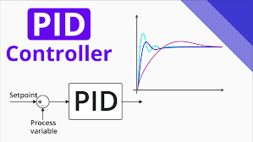
Proportional – integral – derivative controller, or PID controller, is a control loop mechanism that calculates the error from the desired values and the process variable and uses proportional, integral, and derivative terms to minimizes the error.
Proportional term is the main growing factor that gradually closes the gap between the desired value and the process variable. It increases linearly, but easily passes the desired value.
Integral term looks back at past error values to control the growth of error value. As the error value decreases, this integral term will also decrease.
The derivative term then predicts the following growth, and slows down the rapid change in it. The more rapid the erro r value is changing, the more the derivative term influences the growth.

